**Information Retrieval (IR)**

Information Retrieval (IR) is a field of computer science concerned with finding relevant information from a large collection of unstructured or semi-structured data, based on a user’s query. It focuses on retrieving documents that are most relevant to the user's information need, rather than returning exact data values as in traditional databases.

An IR system processes a query, searches through a document corpus, and ranks the results based on relevance using models like the Vector Space Model or Probabilistic Model. It uses techniques such as tokenization, stop-word removal, stemming, and indexing to preprocess documents and queries for efficient matching.

A critical component of IR is the **inverted index**, which maps each term to the list of documents containing it. The relevance of documents to a query is measured using similarity functions like **TF-IDF (Term Frequency–Inverse Document Frequency)** or **cosine similarity**.

The performance of IR systems is evaluated using metrics such as **precision, recall, and F1-score**. Common applications include search engines, digital libraries, and document filtering systems.

## Top 6 Challenges in Information Retrieval (IR)

(2 lines each)

1. **Relevance Determination**  
   Identifying which documents are genuinely relevant to a user's query is difficult due to varying interpretations.  
   User intent may not be clearly expressed, leading to irrelevant results.
2. **Query Understanding**  
   Most queries are short, ambiguous, or vague, making it hard for the system to grasp the actual need.  
   Proper query expansion or reformulation is often required for better retrieval.
3. **Synonymy and Polysemy**  
   Different words can mean the same thing (synonymy), while one word can have multiple meanings (polysemy).  
   This causes confusion in matching user queries to document content.
4. **Scalability**  
   As document collections grow, especially on the web, IR systems must handle huge volumes efficiently.  
   Maintaining fast retrieval with increasing data is a major technical challenge.
5. **Ranking and Evaluation**  
   Ranking documents based on their relevance to a query is complex and subjective.  
   Evaluating the quality of results using metrics like precision and recall is also challenging.
6. **Multilingual and Cross-lingual Retrieval**  
   Users may query in one language while relevant documents are in another.  
   IR systems must bridge language barriers using translation or language models.

## 6 Key Features of an Information Retrieval (IR) System

(2 lines each)

1. **Indexing**  
   The IR system builds an inverted index to map terms to documents quickly.  
   This allows for fast and efficient searching in large datasets.
2. **Query Processing**  
   It processes user queries using techniques like tokenization, stop-word removal, and stemming.  
   This ensures accurate matching between query terms and document terms.
3. **Relevance Ranking**  
   Retrieved documents are ranked based on how relevant they are to the user's query.  
   Techniques like TF-IDF or cosine similarity are commonly used.
4. **User Interface**  
   A clear and interactive interface lets users enter queries and view results easily.  
   It enhances the overall user experience and usability.
5. **Feedback Mechanism**  
   Users can give feedback on search results to help the system learn and improve.  
   This allows dynamic adjustment of ranking and retrieval performance.
6. **Multilingual Support**  
   Some IR systems can process and retrieve documents in multiple languages.  
   This enables users to search across language barriers effectively.

## 6 Main Components of an Information Retrieval (IR) Model

(3 lines each)

1. **Document Collection**  
   This is the source of all documents that the IR system searches through.  
   It can include text files, web pages, research papers, news articles, etc.  
   The quality and size of this collection greatly affect retrieval performance.
2. **Indexing Component**  
   This component processes the documents to extract important terms.  
   It creates an inverted index, which maps words to the documents containing them.  
   Indexing significantly improves the speed and efficiency of search operations.
3. **Query Processor**  
   It handles the user's input query by cleaning and analyzing it.  
   Techniques like tokenization, stemming, and stop-word removal are applied.  
   The processed query is then passed to the retrieval engine for matching.
4. **Retrieval Engine**  
   This engine searches the indexed data to find documents that match the query.  
   It uses matching algorithms like Boolean, vector space, or probabilistic models.  
   The engine retrieves a set of potentially relevant documents.
5. **Ranking Module**  
   Each retrieved document is assigned a relevance score based on similarity to the query.  
   Common scoring techniques include TF-IDF, cosine similarity, and BM25.  
   Documents are ranked from most to least relevant before display.
6. **User Interface**  
   This is where users interact with the IR system to submit queries and view results.  
   It should be intuitive, responsive, and support user feedback.  
   A well-designed interface enhances the overall user experience and effectiveness.

## Boolean Retrieval – Explanation

Boolean retrieval is one of the earliest and simplest models used in Information Retrieval (IR). It is based on Boolean logic, where queries are formed using logical operators such as **AND, OR, and NOT** to retrieve documents that exactly match the specified conditions.

In this model, each document in the collection is represented by a set of terms (words), and each term is either present or absent in a document (binary representation). An inverted index is used to map each term to the list of documents containing it.

### Key Boolean Operators

1. **AND** – Retrieves documents that contain both terms.  
   Example: AI AND Healthcare – returns documents that have both "AI" and "Healthcare".
2. **OR** – Retrieves documents that contain at least one of the terms.  
   Example: Cancer OR Diabetes – returns documents that have either "Cancer" or "Diabetes" or both.
3. **NOT** – Excludes documents containing a certain term.  
   Example: Machine Learning NOT Deep Learning – returns documents with "Machine Learning" but without "Deep Learning".

### Advantages

* Simple to understand and implement.
* Provides exact and predictable results.

### Disadvantages

* Rigid – requires exact term matching.
* No concept of partial matching or ranking by relevance.
* Can return too many or too few documents depending on query structure.

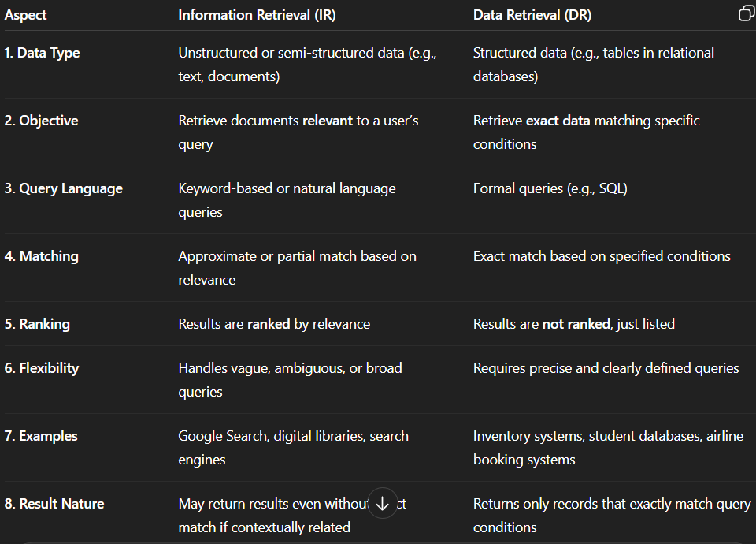

## Text Categorization in IR

Text categorization in IR is the process of automatically assigning predefined labels or categories (like sports, technology, health) to documents. This helps in organizing, filtering, and improving the relevance of retrieved results.

In an IR system, after indexing documents, classification techniques (rule-based or machine learning) are used to categorize them based on content. When a user submits a query, the system can use these categories to better match and rank documents.

It also helps in filtering out irrelevant content, reducing search space, and enabling topic-wise browsing or faceted search for large document collections.

**For example:** A query about “budget updates” will retrieve documents categorized under finance or economy, improving precision and user satisfaction.

### Benefits in IR

* Enhances relevance of search results
* Allows category-based filtering
* Supports topic-wise browsing
* Reduces retrieval time by narrowing search scope

## IR Processes

The IR process involves several key steps that transform raw documents and user queries into meaningful search results:

1. **Document Collection**  
   A large set of unstructured or semi-structured text data (e.g., webpages, articles) is gathered.
2. **Text Preprocessing**  
   Raw text is cleaned using techniques like tokenization, stop-word removal, stemming, or lemmatization to standardize terms.
3. **Indexing**  
   An inverted index is created that maps terms to the list of documents they appear in, allowing faster search.
4. **Query Processing**  
   User queries are parsed and processed (similarly to documents) to prepare them for matching against the index.
5. **Matching/Retrieval**  
   The processed query is compared with the index to retrieve a set of potentially relevant documents.
6. **Ranking**  
   Retrieved documents are ranked using relevance scoring techniques such as TF-IDF, cosine similarity, or BM25.
7. **Result Presentation**  
   Ranked results are shown to the user through an intuitive user interface, often with options for filtering or refining the search.

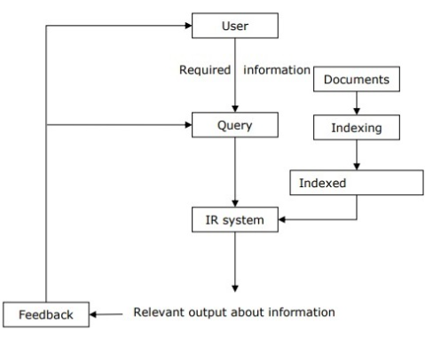

## IR Fields

Information Retrieval overlaps with and draws from multiple technical fields:

1. **Natural Language Processing (NLP)** – Used for understanding and processing human language in documents and queries.
2. **Machine Learning** – Helps in improving ranking algorithms, user personalization, and relevance feedback.
3. **Linguistics** – Supports understanding of syntax, semantics, and grammar of queries and documents.
4. **Data Mining** – Assists in extracting patterns or trends from large document sets.
5. **Human-Computer Interaction (HCI)** – Focuses on designing user interfaces that help users effectively interact with the IR system.
6. **Information Theory** – Provides models and metrics for understanding and evaluating information content and retrieval effectiveness.

## Vector Space Model (VSM) in Information Retrieval

The Vector Space Model is a fundamental model in Information Retrieval (IR) that represents both documents and queries as vectors in a multi-dimensional space. Each dimension corresponds to a term (keyword), and the value along that dimension indicates the importance of the term in the document or query.

### Explanation

In VSM, a document is converted into a vector of weighted terms using schemes like **TF-IDF**. Similarly, the user's query is also represented as a vector. The relevance between a query and a document is then calculated using **cosine similarity** between the two vectors.

* If the cosine of the angle between the vectors is closer to 1, the document is more relevant to the query.
* If the cosine is close to 0, the document is less relevant.

### Key Features

* Supports partial matching – documents don’t need to contain all query terms to be retrieved.
* Allows ranking of results based on similarity scores.
* Captures the importance of terms using weights, improving accuracy over simple Boolean models.

### Advantages

* More flexible and accurate than Boolean retrieval.
* Allows ranked retrieval rather than binary yes/no results.

### Disadvantages

* Ignores word order and semantic meaning.
* High-dimensional vectors can be computationally expensive for large document sets.

## Probabilistic Model and Latent Semantic Indexing Model in Information Retrieval

### 1. Probabilistic Model

The Probabilistic Model of Information Retrieval (IR) is based on the idea that for a given user query, there is a certain probability that a document is relevant. The system tries to estimate this probability and ranks documents accordingly.

The goal is to retrieve documents that have the highest probability of relevance to the user’s query. One of the most well-known models under this category is the **Binary Independence Model (BIM)**.

It assumes that terms occur independently in documents and that each term either appears in the document or does not (binary representation). The probability of a document D being relevant to a query Q is computed based on term statistics such as **term frequency (TF), document frequency (DF), and relevance feedback (if available)**. The retrieval status value (RSV) is calculated for ranking purposes.

**Advantages:**

* Naturally supports ranked retrieval.
* Can incorporate relevance feedback from users.
* Provides a strong theoretical foundation using Bayesian inference.

**Disadvantages:**

* Assumes term independence, which may not be true in real documents.
* Initial probabilities are hard to estimate without prior relevance data.
* May not perform well without user feedback.

### 2. Latent Semantic Indexing (LSI) Model

The Latent Semantic Indexing (LSI) model is an advanced technique used to improve retrieval accuracy by uncovering hidden (latent) relationships between words and documents.

LSI addresses problems like **synonymy** (different words with similar meanings) and **polysemy** (same word with different meanings), which basic keyword-based IR models fail to capture.

The core idea of LSI is to construct a **term-document matrix**, where each entry represents the frequency of a term in a document. This matrix is then decomposed using **Singular Value Decomposition (SVD)**.

SVD reduces the matrix into a lower-dimensional latent semantic space, capturing the most important patterns in word usage across documents. Both documents and queries are mapped into this latent space, and retrieval is done based on semantic similarity, often measured using cosine similarity between vectors.

**Advantages:**

* Captures conceptual meaning, not just keyword matches.
* Improves search results by recognizing synonyms and related terms.
* Helps with dimensionality reduction, making search faster after decomposition.

**Disadvantages:**

* Computationally expensive, especially for large document collections.
* Updating the model with new documents requires re-computing the SVD.
* Results can be harder to interpret due to abstraction.

## Text Categorization Methods (in Information Retrieval)

Text categorization is the process of assigning predefined categories to text documents. It helps organize and retrieve relevant information efficiently.

### 1. Rule-Based Method

This method uses manually created rules to classify texts. Rules are often based on the presence or absence of specific keywords or patterns.

* Example: If a document contains the word “invoice,” assign it to the “Finance” category.
* It is easy to interpret but difficult to scale and maintain.

### 2. Machine Learning-Based Method

Here, a model learns from a set of labeled documents and predicts the category of unseen documents. It requires a training phase with labeled data.  
Common algorithms:

* Naive Bayes Classifier (probability and word frequency)
* Support Vector Machines (SVM)
* K-Nearest Neighbors (KNN)
* Decision Trees
* Neural Networks/Deep Learning

### 3. Dictionary-Based Method

Uses a predefined dictionary of category-specific terms. If the document contains a high proportion of terms from a category's dictionary, it's assigned that category.

* Suitable for domain-specific applications.

### 4. Centroid-Based Method (Rocchio Algorithm)

Each category is represented by a centroid vector (average of all document vectors in the category). A new document is assigned to the category with the closest centroid.

* Efficient and works well with vector space models.

### 5. Ensemble Methods

These methods combine multiple classifiers to improve performance and accuracy.

* Voting-based or weighted combination is used.
* Helps reduce the weaknesses of individual models.

### 6. Deep Learning Approaches

Use models like CNNs, RNNs, or Transformers for complex and high-accuracy text categorization.

* Require large training datasets and high computation power.
* Capture deep semantic and contextual information.